1. 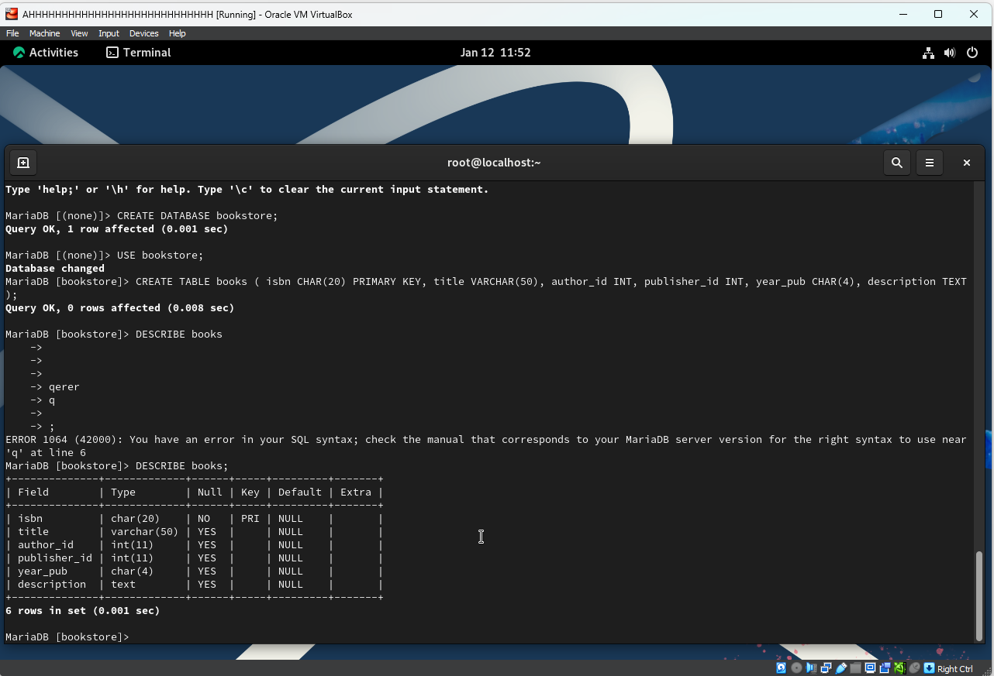

I had to create a new Rocky Linux VM on my computer. Once everything was done, I went to Rocky Linux’s documentation and found [this](https://docs.rockylinux.org/guides/database/database_mariadb-server/) guide on how to install MariaDB. Once installed, I found [this](https://mariadb.com/kb/en/mariadb-basics/) page from the MariaDB website and followed it to create my table. The database is called bookstore and the table is book.

1. 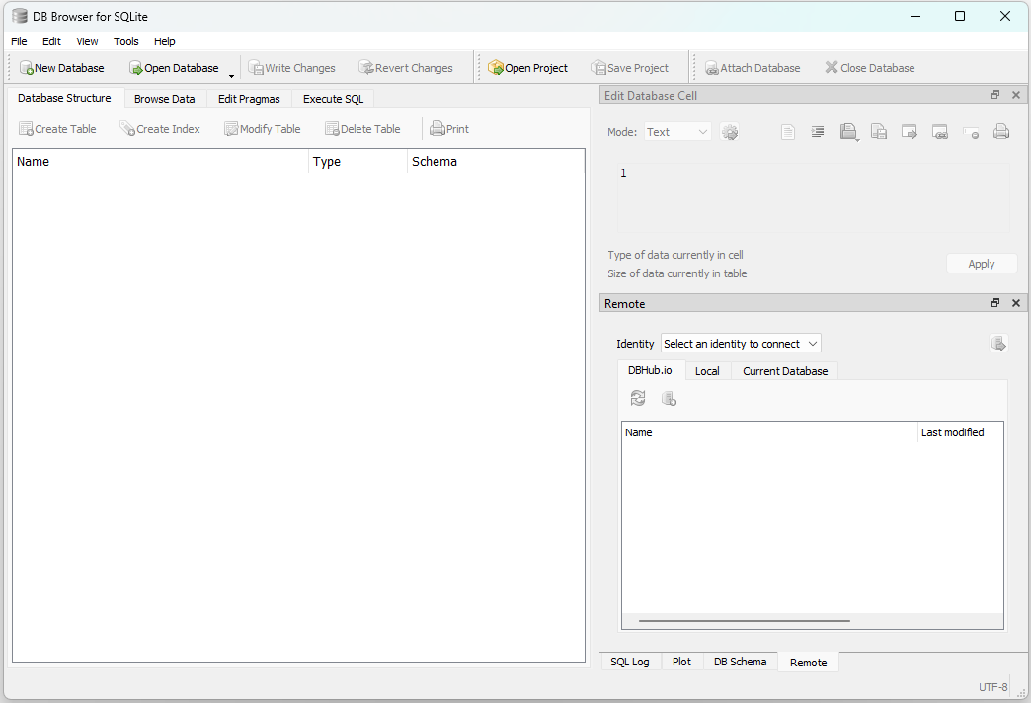

Went to the Db Browser site and downloaded the installer, then installed it.

1. 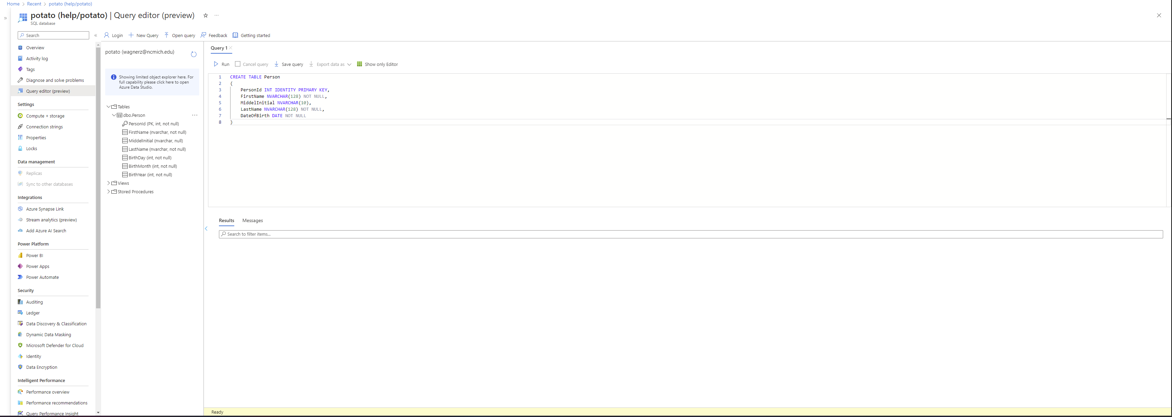

I had to get a subscription to be able to make a table. My table is a persons table made using the query in the picture.

1. 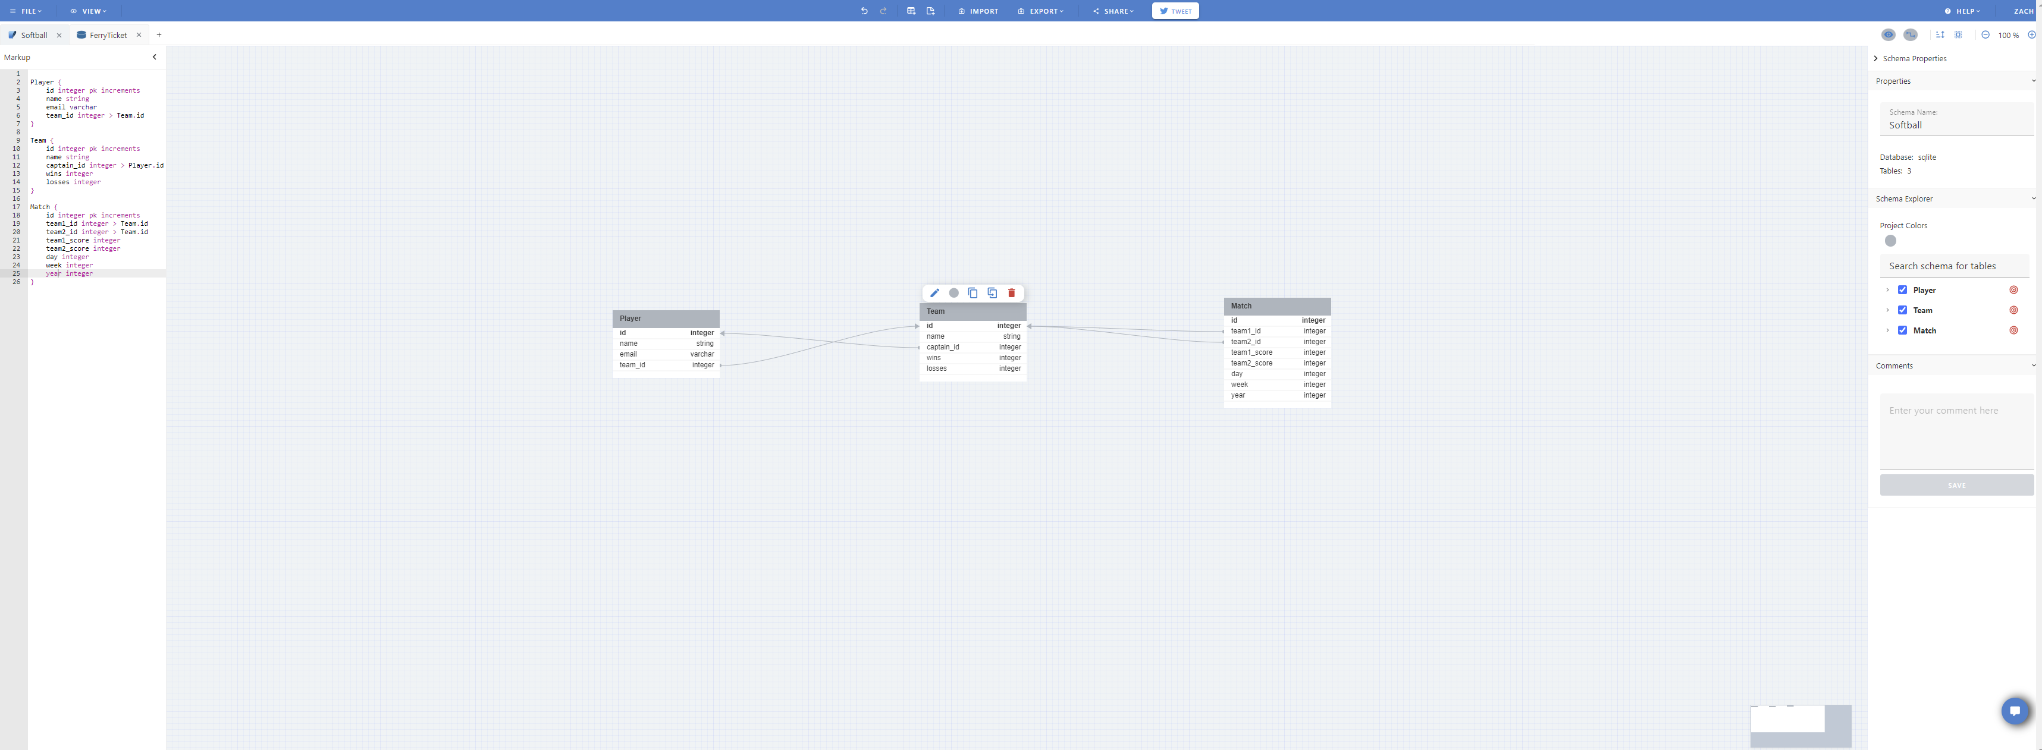

Made a SQLite database with player, team, and match tables in DB designer.

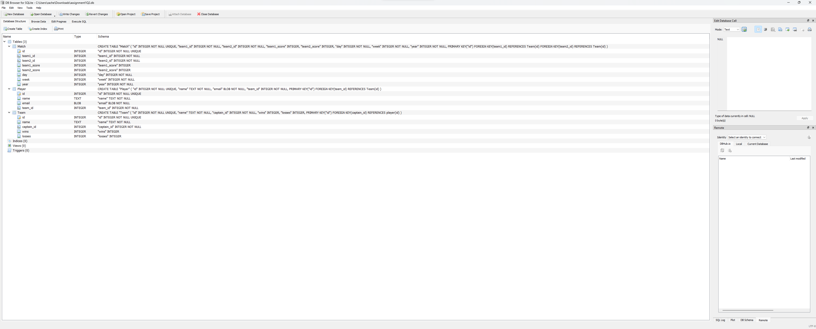

Here is the DB browser database with the same tables after exporting and importing the file. Added data and found no issues with the code.